Manual for Social Audits

*Meghalaya Community Participation and Public Services Social Audit Act 2017*

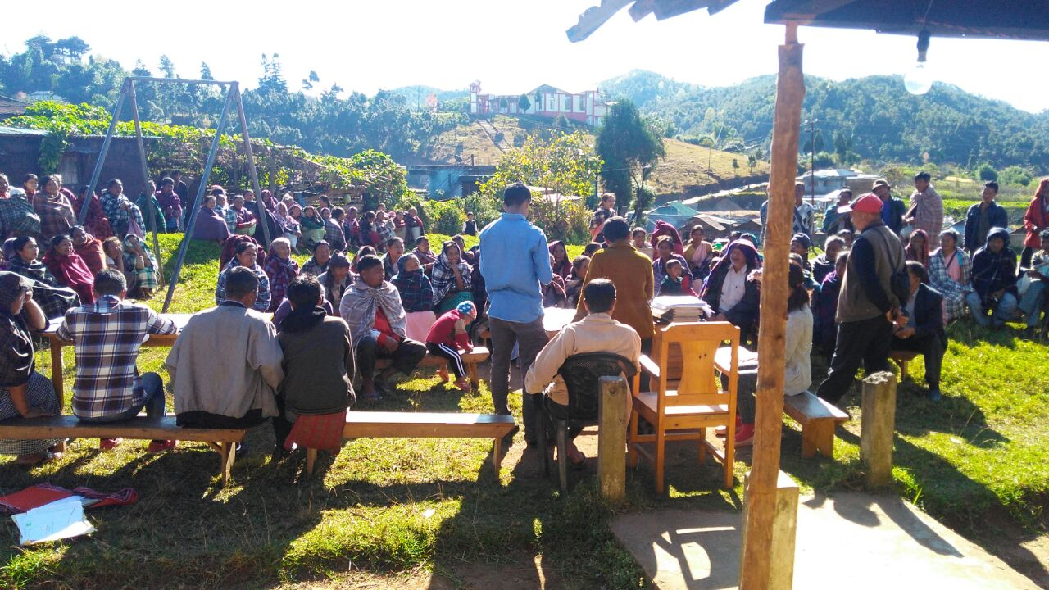

Social audit can be described as verification of the implementation of a programme / scheme and its results by the community with the active involvement of the primary stakeholders. This is done by comparing official records with actual ground realities, with the participation of the community in the verification exercise, and reading out the findings of the verification exercise aloud in a public platform. The social audit process goes beyond accounting for the money that has been spent to examine whether the money was spent properly and has made a difference to people’s lives. The aim is effective implementation and control of irregularities.

A social audit will also ensure that there is no violation of the Act and Rules issued by the

Central and State Government during implementation of the schemes and programmes.

Social audit is conducted by the Village or Locality level Social Audit Committee with the help and support of independent facilitators. The facilitators collate records, verify the records with the people through household verifications, record their grievances, visit worksites, organize information in an easily understandable manner and prepare a social audit report based on their findings to be read out into the village meeting just after completion of the social audit. The village meeting will deliberate on the findings and the implementing departments/ agencies have to respond to the report presented in the village meeting.

Major objectives of the Social Audit under Meghalaya Community Participation and Public Services Social Audit Act include:

a) To facilitate ‘Concurrent Audit’ of development programmes and public services

as specified under Schedule I of the Act.

b) To monitor the effectiveness and efficiency of the implementation of the

development programmes and public services in a time-bound manner and to

initiate course-correction measures wherever necessary

c) To monitor and encourage transparency in the delivery mechanisms and

institutions engaged in the implementation of the developmental programmes

and public services.

d) To ensure that the Social audit process would educate the citizens, make aware

of their rights and entitlements in order to build their confidence and secure

their participation.

e) To enhance citizen’s ownership in the development initiatives taken up by the

Government in the true spirit of participatory Democracy.

f) The Social Audit shall be used for the purpose of finding the facts at the field

level in the implementation of the programmes and to improve upon them.

g) To seek suggestions from the people on ways and means of improving the

implementation of the development programmes and public services

h) To provide a platform for airing of public grievances and ensure a time-bound

redress of the same.

i) To review delivery of public services and implementation of Government

schemes and programmes.

j) To ensure timely review and concurrent course-correction in the delivery of

schemes and programmes to achieve realization of desired development

outcome.

k) Inform and educate people about their rights and entitlements under the

schemes and programmes as mentioned at Schedule – I of the Act in course of

conducting social audit.

l) Provide a collectively platform such as social audit village meeting, for people to

express their needs and grievances and settlement of the issues / grievances

raised.

m) Promote people’s participation in all stages of the implementation of the

schemes and programme.

n) Strengthen participation in Village meeting, make it an inclusive and

participatory institution and make it a platform for positive collective action

through social audit.

o) Improve the capacity of local stake-holders who are participants in the social

audit.

p) Strengthen the scheme / programme by deterring corruption and improving

implementation.

q) Controlling leakages in implementation of the scheme / programme.

r) Detecting malfunctioning in the implementation in the presence of people and

promoting corrective action.

s) Strengthening local governance.

To conduct social audits requires the following main processes:

1. Formats for social audit
2. Formation of social audit teams
3. Initiation Meetings in villages
4. Sharing of Information on Entitlements
5. Preparation for Public Hearing
6. Public Hearing and Registering Grievances
7. Follow Up
8. Formats for Social Audit

As mandated under Section 15(b) of the Act, information required for conducting social audits is to be provided by the respective Nodal Officers of departments . The information is to be made available in the formats developed by Meghalaya Society for Social Audit and Transparency (MSSAT). MSSAT will provide the Social Audit Teams with the following:

1. Social Audit Formats
2. List of Entitlements
3. Specific Grievance Redress form (if any)

The following are the Social Audit Formats, which will be partially pre-filled by the Departments themselves using original documents. Blank sheets will also be provided for recording findings and evidence based on the template provided for each scheme.

**Public Distribution System**

|  |  |  |
| --- | --- | --- |
| Village: | Block: | District: |

1) Basic Details: This format will be verified in Locality meetings and Focus Group Discussions. Sections of this format need to be filled by visiting the FPS Shop during working hours. Everything has to be read out once. Only v to viii and xvi-xvii has to be verified and the perception based on consensus must be noted in the answer sheets. If there is a major division in opinion, that too should be noted.

|  |  |  |
| --- | --- | --- |
|  | Information from official records / Department | *Verification data to be filled by Social Audit Team* |
| 1. License Number |  | N/A |
| 1. Dealer Name |  | N/A |
| 1. Shop Name |  | N/A |
| 1. Name of the shop supervisor |  | N/A |
| 1. Timings of opening and closing of the FPS |  |  |
| 1. Days of operation |  |  |
| 1. Does the shop have a public information board displaying the opening hours & entitlements for different types of households? |  |  |
| 1. Does the list of households along with their type (AAY, Priority HH, non-NFSA) displayed in the ration shop or printed on the wall? |  |  |
| 1. Number of Priority Households |  | N/A |
| 1. Number of Antyodaya Anna Yojana Households |  | N/A |
| 1. Number of Annapurna Households |  | N/A |
| 1. Number of households receiving non-NFSA rice |  | N/A |
| 1. Number of households receiving non-NFSA wheat |  | N/A |
| 1. Number of households receiving sugar |  | N/A |
| 1. Number of households receiving kerosene |  | N/A |
| 1. Is the Village Vigilance Committee functional? |  |  |
| 1. Details of complaints received by higher officials regarding the functioning of this shop and action taken on them |  |  |

2) Stock Table: This information should also be read out/shared/displayed in the locality meetings and on the day of the public hearing. Any major discrepancy should be noted, in the answer sheets, even if it is not specific. For instance, people may say that no wheat has come for months without knowing the specific number of months.

|  |  |  |  |  |  |  |  |
| --- | --- | --- | --- | --- | --- | --- | --- |
|  |  | Apr 2017 | May 2017 | June 2017 | July 2017 | Aug 2017 | Sep 2017 |
| AAY Rice | Opening Balance |  |  |  |  |  |  |
| Kgs Received |  |  |  |  |  |  |
| Kgs Distributed |  |  |  |  |  |  |
| Closing Balance |  |  |  |  |  |  |
| PHH Rice | Opening |  |  |  |  |  |  |
| Received |  |  |  |  |  |  |
| Distributed |  |  |  |  |  |  |
| Closed |  |  |  |  |  |  |
| Annapurna Rice | Opening |  |  |  |  |  |  |
| Received |  |  |  |  |  |  |
| Distributed |  |  |  |  |  |  |
| Closed |  |  |  |  |  |  |
| Non-NFSA Rice | Opening |  |  |  |  |  |  |
| Received |  |  |  |  |  |  |
| Distributed |  |  |  |  |  |  |
| Closed |  |  |  |  |  |  |
| Non-NFSA Wheat | Opening |  |  |  |  |  |  |
| Received |  |  |  |  |  |  |
| Distributed |  |  |  |  |  |  |
| Closed |  |  |  |  |  |  |
| Sugar | Opening |  |  |  |  |  |  |
| Received |  |  |  |  |  |  |
| Distributed |  |  |  |  |  |  |
| Closed |  |  |  |  |  |  |
| Kerosene | Opening |  |  |  |  |  |  |
| Received |  |  |  |  |  |  |
| Distributed |  |  |  |  |  |  |
| Closed |  |  |  |  |  |  |

3) List of Village Vigilance Committee of this Fair Price Shop: Composition of Committee should be read out. People must be asked whether   
- they knew about this committee  
- does this committee function   
- have they ever approached this committee with grievances  
Also, read out the roles and responsibilities of this committee as per norms.

|  |  |
| --- | --- |
| Name of member | Designation |
|  |  |
|  |  |
|  |  |

4) Beneficiary Data:   
- Tell people about entitlements under NFSA   
- Ask people whether they get entitlements as per norms.   
- Read out the beneficiary distribution register for FY 2017-18 for the locality   
- Take individual applications and grievances   
- If given month wise, total the amount distributed for the year and read out that figure.

Note: For 2017-18, fill data from April to September

|  |  |  |  |  |  |
| --- | --- | --- | --- | --- | --- |
| Ration card ID number | Name of head of household as per ration card | Year | Type of Household (AAY / PHH / non-NFSA) | Rice/Wheat/  Sugar/Kerosene as per official records | *Rice/Wheat/*  *Sugar/Kerosene as per household member / ration card* |
|  |  | 2015-16 |  |  |  |
| 2016-17 |  |  |  |
| 2017-18 |  |  |  |

**National Social Assistance Programme (NSAP)**

There are two kinds of pension (NSAP and CM pension scheme) that are distributed by two different departments in Meghalaya. Therefore, while verifying pensions, both lists will have to be available for verification so that all pensioners are able to check the information and records.

1. List of pension recipients: While going from house to house, an attempt should be made to meet and talk to any disabled or elderly person to ask them if they are receiving their pensions, and if they have any particular problem with sanction or delivery. Those who can come to the locality meeting, should be requested to come with their documents (bank or post office pass book, pension slip, receipts etc). For those who can’t come, a family member can be requested to bring documents and come to the meeting. At the locality meeting, the eligibility criteria, the list of beneficiaries from the locality should be read out, and a list of excluded eligible potential beneficiaries should be prepared. Grievances should be written out, applications should be prepared where necessary

|  |  |  |  |  |  |  |  |  |  |
| --- | --- | --- | --- | --- | --- | --- | --- | --- | --- |
| Name of beneficiary | Beneficiary Age | Pension category | Monthly Pension Amount as per record | *Monthly pension amount as per beneficiary* | Pension start date as per records | *Pension Start Date as per beneficiary* | *Does the person get pension every month without delay? (Yes / No)* | *Does beneficiary pay any amount to post office / bank while withdrawing (Yes / No)* | *Remarks* |
|  |  |  |  |  |  |  |  |  |  |
|  |  |  |  |  |  |  |  |  |  |
|  |  |  |  |  |  |  |  |  |  |

1. SECC List: One objective of the social audit exercise is to include those eligible but currently not availing benefits. Access the BPL/SECC List which will provide a list of all those who are eligible to get pension. Visit them, verify whether they have made applications to the administration and help them fill the application forms.

|  |  |  |  |  |  |  |
| --- | --- | --- | --- | --- | --- | --- |
| Names of eligible beneficiary as per SECC list/BPL List | Whether eligible beneficiary has applied | Date of Application | Status [Verified and Accepted/Verified and Rejected/Not Verified) | Date of Verification (if Verified) | Reason for Rejection (If Rejected) | *Remarks* |
|  |  |  |  |  |  |  |
|  |  |  |  |  |  |  |
|  |  |  |  |  |  |  |

3) List of applicants (other than in the SECC/BPL list) who have applied for pension : If possible access any register which records names of people who have applied and verify the status of their application.

|  |  |  |  |  |  |
| --- | --- | --- | --- | --- | --- |
| Names of applicant | Date of Application | Status [Verified and Accepted/Verified and Rejected/Not Verified) | Date of Verification (if Verified) | Reason for Rejection (If Rejected) | *Remarks* |
|  |  |  |  |  |  |
|  |  |  |  |  |  |
|  |  |  |  |  |  |
|  |  |  |  |  |  |
|  |  |  |  |  |  |

**Pradhan Mantri Awas Yojana**

|  |  |  |
| --- | --- | --- |
| Village: | Block: | District: |

1. List of beneficiaries for all houses sanctioned in 2015-16, 2016-17, 2017-18:   
   Visit all beneficiaries who have been sanctioned house under PMAY in 2016-17 and 2017-18 and fill the following format.

|  |  |  |  |  |  |  |  |  |
| --- | --- | --- | --- | --- | --- | --- | --- | --- |
| Name of beneficiary and year of allotment | *Was beneficiary selected as per DRDA waiting list or SECC List? (Yes / No)* | Status of house (Started / Plinth / Lintel / Completed) | *Status of house as per field verification (Started / Plinth / Lintel / Completed)* | Installment Number | Amount Disbursed & Date | *Amount received and date* | *Whether the beneficiary had to pay any amount for sanction of house or to get instalment?* | *Remarks* |
|  |  |  |  | 1st Installment |  |  |  |  |
| 2nd Installment |  |  |
| 3rd Installment |  |  |
|  |  |  |  | 1st Installment |  |  |  |  |
| 2nd Installment |  |  |
| 3rd Installment |  |  |

1. List of beneficiaries eligible for housing under PMAY norms from the SECC list: Read out the waiting list of eligible HHs for PMAY as prepared by SECC. Assess whether HHs sanctioned are in order of priority as mentioned in the SECC list. Take down individual applications for people who may be eligible as per norms but their names are not reflected in the SECC list.

|  |  |  |  |
| --- | --- | --- | --- |
| Name of eligible beneficiary as per SECC | Waiting List number as per DRDA | Has a house been allotted? If yes, sanction year | *Remarks* |
|  |  |  |  |
|  |  |  |  |
|  |  |  |  |
|  |  |  |  |
|  |  |  |  |
|  |  |  |  |

**Sarva Shiksha Abhiyan**

|  |  |  |
| --- | --- | --- |
| Village: | Block: | District: |

Name of School:   
School Management Type: Govt/SSA/Govt. Aided   
DISE Code:

1) A copy of the latest DISE report for the school should be enclosed.

2) Basic Details of the school

The following information must be verified by visiting the school during school hours without disturbing teaching.   
In addition, there are certain points that can be verified only through a Focus Group Discussion with both 1. Parents and Children 2. Teachers separately  
Certain issues such as attendance of teachers on a regular basis and quality of teaching, which cannot be easily verified and quantified, must be recorded in writing by individuals/groups with their signatures. This can become a point of discussion in the social audit public hearing.

|  |  |  |
| --- | --- | --- |
|  | Data as per official record / department | *Data on verification* |
| 1. Total Boys enrolled: |  | Number of boys present: |
| 1. Total Girls enrolled: |  | Number of girls present: |
| 1. Number of drop-out children in the area: |  |  |
| 1. Number of out-of-school children in the area: |  |  |
| 1. Number of sanctioned teachers for this school: |  |  |
| 1. Number of appointed teachers in this school: |  | Number of teachers present: |
| 1. Names of teachers: |  |  |
| 1. Names of teachers who do not come to school regularly: |  |  |
| 1. Is the school easily accessible to students? |  |  |
| 1. Names of Children with special needs |  |  |
| 1. Are the children with special needs provided adequate support in school? |  |  |
| 1. Month when text books were distributed to children |  |  |
| 1. Month when uniforms were distributed to children |  |  |
| 1. Number of class rooms: |  |  |
| 1. Does each classroom have a black board? |  |  |
| 1. Does each classroom have desks and chairs? |  |  |
| 1. Does school have a play ground? |  |  |
| 1. Does play ground have a boundary? |  |  |
| 1. Does play ground have a level playing field? |  |  |
| 1. Does school have a boundary wall? |  |  |
| 1. Are the playground boundary walls and school boundary walls made of pakka material? |  |  |
| 1. Does school have a regular source of clean drinking water? |  |  |
| 1. Number of functional toilets? |  |  |
| 1. Number of functional urinals? |  |  |
| 1. Does the school have separate toilets for boys and girls? |  |  |
| 1. Do all toilets have a roof? |  |  |
| 1. Do all toilets have a functional door? |  |  |
| 1. Do all toilets have a water source? |  |  |
| 1. Are toilets cleaned regularly? |  |  |
| 1. Honorarium for the cook: |  |  |
| 1. Honorarium for the helper: |  |  |
| 1. Is the cooking staff paid regularly? |  |  |
| 1. Date when the School Management Committee was formed / reconstituted |  |  |
| 1. Is the list of SMC members displayed in the school? |  |  |
| 1. Date when the last SMC meeting was held |  |  |
| 1. Was any training provided to SMC members in the last year? |  |  |
| 1. Are the decisions taken in the SMC meeting recorded in the register? |  |  |
| 1. Are actions taken on the decisions taken and is that recorded in the register? |  |  |
| 1. Date of the last Parent Teacher Association meeting |  |  |
| 1. Number of parents who attended the last Parent Teacher Association meeting |  |  |
| 1. Details of complaints received by higher officials and action taken on them from them school |  |  |

1. Composition of school management Committee: Composition of Committee should be read out. People must be asked whether

- they knew about this committee  
- does this committee function   
- have they ever approached this committee with grievances

|  |  |
| --- | --- |
| Name of member | Designation |
|  |  |
|  |  |
|  |  |

1. Copy of the Development Plan prepared by the SMC : Share this plan with parents and children. Ask them if they have ever seen this and was it prepared on the basis of a consultation with them.
2. Allocation and expenditure of SMC: Read out this information in the locality meeting.

|  |  |  |  |  |
| --- | --- | --- | --- | --- |
| Type of fund | Received from where | Date of receipt | Amount received | Amount spent |
|  |  |  |  |  |
|  |  |  |  |  |
|  |  |  |  |  |
|  |  |  |  |  |
|  |  |  |  |  |

1. Allocation and utilization of grants for FY 2016-17: Read this information out in the locality meeting. Verify this information through school visit and locality meeting. Your questions should concern both utility, quality and verification of expenses recorded.

|  |  |  |  |  |  |  |
| --- | --- | --- | --- | --- | --- | --- |
| Name of Grant (School Grant, Maintenance Grant, Teacher Grant) | Total amount allocated as per records | Item of expenditure as per records | Amount of expenditure undertaken on the item as per records | Date of Bill as per records | Name of firm which supplied as per records | *Was item found on site and comments* |
|  |  |  |  |  |  |  |
|  |  |  |  |  |  |  |
|  |  |  |  |  |  |  |
|  |  |  |  |  |  |  |
|  |  |  |  |  |  |  |
|  |  |  |  |  |  |  |

1. Construction work in School: Read this information out in the locality meeting. Verify this information through school visit and locality meeting. Your questions should concern both utility, quality and verification of expenses recorded.

|  |  |  |  |
| --- | --- | --- | --- |
| Work item | Sanctioned amount | Actual expenditure as per records (item wise material procured and rate of each item procured) | *Remarks based on verification on field* |
|  |  |  |  |
|  |  |  |  |
|  |  |  |  |
|  |  |  |  |
|  |  |  |  |
|  |  |  |  |

1. Distribution of entitlements (FY 2017-18) : Read this information out in the locality meeting and verify. Try and make sure that the locality meeting has children present.

|  |  |  |  |  |  |  |  |  |
| --- | --- | --- | --- | --- | --- | --- | --- | --- |
| Name of student | Name of Parent | Class | Textbook distributed as per Records | *Textbooks received as per student* | Uniform distributed as per records | *Uniform received as per student* | Scholarship distributed as per records | *Scholarship received as per student* |
|  |  |  |  |  |  |  |  |  |
|  |  |  |  |  |  |  |  |  |
|  |  |  |  |  |  |  |  |  |
|  |  |  |  |  |  |  |  |  |
|  |  |  |  |  |  |  |  |  |

**Mid Day Meal Scheme**

|  |  |  |
| --- | --- | --- |
| Village: | Block: | District: |

Name of School:  
School Management Type: Govt/SSA/Govt. Aided  
DISE Code:

1) Basic Details: The following information must be verified by visiting the school during school hours without disturbing teaching.   
In addition, there are certain points that can be verified only through a Focus Group Discussion with both 1. Parents and Children 2. Teachers separately  
Certain issues such as quality and quantity which cannot be easily verified and quantified, must be recorded in writing by individuals/groups with their signatures. This can become a point of discussion in the social audit public hearing**.**

|  |  |  |
| --- | --- | --- |
|  | Data as per official record / supervisor | *Data on verification* |
| Number of cooks: |  |  |
| Number of helpers: |  |  |
| Names of cooks: |  |  |
| Names of helpers: |  |  |
| Honorarium for the cook: |  |  |
| Honorarium for the helper: |  |  |
| Is the cooking staff paid regularly? |  |  |
| Name of teacher supervising the cook: |  |  |
| Is the menu for the MDM displayed in the school: |  |  |
| Is the MDM as per the menu? |  |  |
| Is an egg supplied as part of the MDM once a week? |  |  |
| Is a fruit supplied as part of the MDM once a week? |  |  |
| Is the School Management Committee formed? |  |  |
| Does the MDM monitoring commitee meet every month? |  |  |
| Does the MDM monitoring committee the MDM program? |  |  |
| Are the decisions taken in the MDM monitoring committee meeting recorded in the register? |  |  |
| Are actions taken on the decisions taken and is that recorded in the register? |  |  |
| Details of complaints received by higher officials and action taken on them |  |  |

2) Composition of MDM Monitoring Committee: Composition of Committee should be read out. People must be asked whether   
- they knew about this committee  
- does this committee function   
- have they ever approached this committee with grievances

|  |  |
| --- | --- |
| Name of member | Designation |
|  |  |
|  |  |
|  |  |

3) Attendance Data: The following table must be filled by matching School Enrollment Register, School Attendance Register and MDM Register

|  |  |  |  |  |  |  |  |  |  |  |
| --- | --- | --- | --- | --- | --- | --- | --- | --- | --- | --- |
| Month | Number of days in the month | Enrolment as per register | | | Number attended as per register | | | No of children who had MDM as per register | | |
|  |  | Boys | Girls | Total | Boys | Girls | Total | Boys | Girls | Total |
|  |  |  |  |  |  |  |  |  |  |  |
|  |  |  |  |  |  |  |  |  |  |  |
|  |  |  |  |  |  |  |  |  |  |  |

4) Grain and Cash register data: Read this information out in the locality meeting.

|  |  |  |  |  |  |  |  |  |  |  |  |  |
| --- | --- | --- | --- | --- | --- | --- | --- | --- | --- | --- | --- | --- |
| Month | Food grain as per register | | | | Cooking cost as per register | | | | Cook-cum-helper as per honorarium as per register | | | |
|  | Opening Balance | Received | Utilized | Balance | Opening Balance | Received | Utilized | Balance | Opening Balance | Received | Utilized | Balance |
|  |  |  |  |  |  |  |  |  |  |  |  |  |
|  |  |  |  |  |  |  |  |  |  |  |  |  |
|  |  |  |  |  |  |  |  |  |  |  |  |  |

5) List of beneficiaries as per MDM register (FY 2017-18): Read this list out in the locality meeting and verify.

|  |  |  |  |  |  |  |
| --- | --- | --- | --- | --- | --- | --- |
| Name of student as per MDM Register | Name of parent / guardian | Class | *Whether actual or not - as per beneficiary* | *Food Regularity* | *Food Quality* | *Food Quantity* |
|  |  |  |  |  |  |  |
|  |  |  |  |  |  |  |
|  |  |  |  |  |  |  |
|  |  |  |  |  |  |  |
|  |  |  |  |  |  |  |
|  |  |  |  |  |  |  |
|  |  |  |  |  |  |  |

6) Access the MDM Register and verify (approximately) the total number of times the child has accessed mid day meal in the last 3 months.

**Integrated Child Development Scheme (ICDS)**

|  |  |  |
| --- | --- | --- |
| Village: | Block: | District: |

Name of Anganwadi Center:

The following information must be verified by visiting the AWC during working hours without disturbing work.   
In addition, there are certain points that can be verified only through a Focus Group Discussion with both 1. Parents and Children 2. Anganwadi Workers separately  
Certain issues such as regularity and quality which cannot be easily verified and quantified, must be recorded in writing by individuals/groups with their signatures. This can become a point of discussion in the social audit public hearing.

1) Basic Details of the Anganwadi

|  |  |  |
| --- | --- | --- |
|  | Data as per official record / department | Data on verification |
| Total Boys enrolled: |  | Number of boys present: |
| Total Girls enrolled: |  | Number of girls present: |
| Name of anganwadi worker: |  |  |
| Name of helper: |  |  |
| Name of lady supervisor: |  |  |
| Does the anganwadi have a working weighing machine? |  |  |
| Does the anganwadi have play material for the children? |  |  |
| Does the anganwadi have educational material for the children? |  |  |
| Is the growth monitoring register maintained? |  |  |
| Does anganwadi have a separate kitchen space? |  |  |
| Does anganwadi have access to safe water? |  |  |
| Does anganwadi have a toilet? |  |  |
| Is the toilet child-friendly? |  |  |
| Is the daily anganwadi menu displayed in the anganwadi? |  |  |
| Opening times of the anganwadi: |  |  |
| Opening days of the anganwadi: |  |  |
| Has a community monitoring committee been formed? |  |  |
| Has the community monitoring committee been provided training? |  |  |
| Is the list of community monitoring committee members displayed in the anganwadi? |  |  |
| Are the decisions taken in the community monitoring committee meeting recorded in the register? |  |  |
| Are actions taken on the decisions taken and is that recorded in the register? |  |  |
| Details of complaints received by higher officials and action taken on them |  |  |

**2**) Composition of community monitoring committee: Composition of Committee should be read out. People must be asked whether   
- they knew about this committee  
- does this committee function   
- have they ever approached this committee with grievances

|  |  |
| --- | --- |
| Name of member | Designation |
|  |  |
|  |  |
|  |  |

3) Take home Rations for children: Read the following information out in the locality meeting and verify.

|  |  |  |  |  |
| --- | --- | --- | --- | --- |
| Name of child | Names of parents | Year | THR distributed as per records | THR distributed as per parents |
|  |  | 2015-16 |  |  |
| 2016-17 |  |  |
| 2017-18 (Apr – Sep) |  |  |
|  |  | 2015-16 |  |  |
| 2016-17 |  |  |
| 2017-18 (Apr – Sep) |  |  |
|  |  | 2015-16 |  |  |
| 2016-17 |  |  |
| 2017-18 (Apr – Sep) |  |  |

4) Take home Rations for Pregnant Women: : Read the following information out in the locality meeting and verify.

|  |  |  |  |  |
| --- | --- | --- | --- | --- |
| Name of the pregnant woman | Names of husband / parent | Year | THR distributed as per records | THR distributed as per pregnant women |
|  |  | 2015-16 |  |  |
| 2016-17 |  |  |
| 2017-18 (Apr – Sep) |  |  |
|  |  | 2015-16 |  |  |
| 2016-17 |  |  |
| 2017-18 (Apr – Sep) |  |  |
|  |  | 2015-16 |  |  |
| 2016-17 |  |  |
| 2017-18 (Apr – Sep) |  |  |

5) List of currently enrolled children attending anganwadi: : Read the following information out in the locality meeting and verify.

|  |  |  |  |  |  |  |  |  |
| --- | --- | --- | --- | --- | --- | --- | --- | --- |
| Name of child | Child age | Names of parents | Is child attending anganwadi? | Is the anganwadi regularly open? | Is the child given a healthy morning snack? | Is the child given a hot cooked meal every day? | Quality of care provided at the anganwadi (Good / Satisfactory / Not Satisfactory) | Quality of food given to the child (Good / Satisfactory / Not Satisfactory) |
|  |  |  |  |  |  |  |  |  |
|  |  |  |  |  |  |  |  |  |
|  |  |  |  |  |  |  |  |  |

6) Attendance Data: Read out the following information in the locality meeting:

From April 2015 to Sept 2017

|  |  |  |  |  |  |  |  |
| --- | --- | --- | --- | --- | --- | --- | --- |
| Month | Number of days in the month | Enrolment as per register | | | Number attended as per register | | |
|  |  | Boys | Girls | Total | Boys | Girls | Total |
|  |  |  |  |  |  |  |  |
|  |  |  |  |  |  |  |  |
|  |  |  |  |  |  |  |  |

7) Grain and Cash register data: Read out the following information in the locality meeting

From April 2015 to Sept 2017

|  |  |  |  |  |  |  |  |  |
| --- | --- | --- | --- | --- | --- | --- | --- | --- |
| Month | Food grain as per register | | | | Food and cooking cost as per register | | | |
|  | Opening Balance | Received | Utilized | Balance | Opening Balance | Received | Utilized | Balance |
|  |  |  |  |  |  |  |  |  |
|  |  |  |  |  |  |  |  |  |
|  |  |  |  |  |  |  |  |  |

**Health**

|  |  |  |
| --- | --- | --- |
| Village: | Block: | District: |

1) ASHA details: Verify the following information by interacting with the ASHA Worker

|  |  |  |
| --- | --- | --- |
|  | Information from official records / Department | *Verification data and remarks by Social Audit Team* |
|  |  |  |
| Name of the health worker (ASHA) |  |  |
| Date of appointment of ASHA |  |  |
| Is the ASHA from the same village |  |  |
| Number of trainings provided to ASHA |  |  |
| Total amount paid to ASHA in 2016-17 |  |  |
| Total amount paid to ASHA in 2017-18 |  |  |
| Does the ASHA maintain Village Health Nutrition Day Register? |  |  |

**2**) VHNSC Committee members and Committee functioning ; Composition of Committee should be read out. People must be asked whether   
- they knew about this committee  
- does this committee function   
- have they ever approached this committee with grievances

|  |  |
| --- | --- |
| Names of committee members | Designation |
|  |  |
|  |  |
|  |  |
|  |  |

3) VHNSC functioning: Verify the following information by interacting with the VHNSC and locality meeting

|  |  |  |
| --- | --- | --- |
|  | Information from official records / Department | *Verification data and remarks by Social Audit Team* |
| When was the VHNSC of this village constituted? |  |  |
| Was any training provided to the VHNSC members? |  |  |
| Does the VHNSC committee meet regularly? |  |  |
| Date of the last VHNSC committee meeting |  |  |
| Are the decisions of the VHNSC committee written down in the register? |  |  |
| Is the action taken on the decisions written down in the register? |  |  |
| Is the VHND conducted every month |  |  |
| Date of the last VHND |  |  |

4) VHNSC Account details: Read the following information out in the locality meeting

|  |  |  |  |  |  |
| --- | --- | --- | --- | --- | --- |
| Year | Opening balance | Sanctioned amount in the FY | Total amount received in the FY | Total expenditure in the FY | Closing Balance |
| 2015-16 |  |  |  |  |  |
| 2016-17 |  |  |  |  |  |
| 2017-18 |  |  |  |  |  |

5) Details of expenditure by VHNSC in 2016-17: Read the information out in the locality meeting and verify through physical inspection

|  |  |  |
| --- | --- | --- |
| Item of expenditure | Amount | *Verification data and remarks by Social Audit Team* |
|  |  |  |
|  |  |  |
|  |  |  |
|  |  |  |

6) Sub Center details: Verify the following by visiting the Sub Center. Issues from xix-xxiii should also be verified through a locality meeting

|  |  |  |
| --- | --- | --- |
|  | Information from official records / Department | *Verification data and remarks by Social Audit Team* |
| 1. Name and Location of the sub center catering to this village |  |  |
| 1. Name and designation of staff in the sub center |  |  |
| 1. Is a quarter available for the ANM to stay in the village? |  |  |
| 1. Does the ANM stay in the quarter? |  |  |
| 1. Does the sub center have electricity? |  |  |
| 1. Does the sub center have water supply? |  |  |
| 1. Does the sub center have a thermometer? |  |  |
| 1. Does the sub center have a stethoscope? |  |  |
| 1. Does the sub center have a weighing machine? |  |  |
| 1. Does the sub center have a Blood Pressure measuring device? |  |  |
| 1. Does the sub center have clean toilet? |  |  |
| 1. Does the sub center have a sterilizer (autoclave)? |  |  |
| 1. Does the sub center have deliver disposal kits (DD Kits)? |  |  |
| 1. Does the sub center have a delivery room and other equipments? |  |  |
| 1. Does the sub center have a vaccine kit? |  |  |
| 1. Does the su b center have an ice pack box? |  |  |
| 1. Does the sub center provide immunizations? |  |  |
| 1. Is there a fixed day when immunization is provided at the sub center? If yes, which day is it? |  |  |
| 1. Does the ANM visit this village on a particular day in the week? If yes, specify the day |  |  |
| 1. Are any family planning services provided at the sub center? |  |  |
| 1. List of other services provided at the sub center |  |  |
| 1. Are all services at the sub-center free of cost? |  |  |
| 1. Does the sub center have notice boards with health information? |  |  |
| 1. Is the information about services provided, timings and citizen charter displayed in the center for the public? |  |  |

7) List of all women who gave birth in 2015-16, 2016-17, 2017-18: This must be verified through a door to door visit of beneficiaries for 2017-18

|  |  |  |  |  |  |  |  |  |
| --- | --- | --- | --- | --- | --- | --- | --- | --- |
| Name of the woman | Name of the husband / father | Woman’s Age | Date of delivery | Where did it happen? | JSY amount given to her | Did ASHA support her | Was she given all the immunizations? | *Verification Data & remarks by the Social Audit Team* |
|  |  |  |  |  |  |  |  |  |
|  |  |  |  |  |  |  |  |  |
|  |  |  |  |  |  |  |  |  |
|  |  |  |  |  |  |  |  |  |
|  |  |  |  |  |  |  |  |  |
|  |  |  |  |  |  |  |  |  |
|  |  |  |  |  |  |  |  |  |

8) List of children who have to be given vaccinations: This must be verified through a door to door visit of beneficiaries for FY 2017-18

|  |  |  |  |  |  |
| --- | --- | --- | --- | --- | --- |
| Name of child | Name of parent | Age | Have all immunizations been given to this child? | List of vaccinations given in the last 3 months | *Verification Data & remarks by the Social Audit Team* |
|  |  |  |  |  |  |
|  |  |  |  |  |  |
|  |  |  |  |  |  |

9) List of all pregnant women : This must be verified through a door to door visit of beneficiaries for FY 2017-18

|  |  |  |  |  |  |  |  |
| --- | --- | --- | --- | --- | --- | --- | --- |
| Name of woman | Name of husband | Age | Pregnancy month | Number of ante-natal check-ups done so far | Have all immunizations been given to this woman? | List of vaccinations given in the last 3 months | *Verification Data & remarks by the Social Audit Team* |
|  |  |  |  |  |  |  |  |
|  |  |  |  |  |  |  |  |
|  |  |  |  |  |  |  |  |

10) List of all deaths in 2015-16, 2016-17, 2017-18: This is not to be publicly read out. This is to understand the frequent causes of death, and whether the Administration could have done something/do something to prevent it.

|  |  |  |  |
| --- | --- | --- | --- |
| Name of the person | Name of father / husband / wife | Age of the person | Reason for death |
|  |  |  |  |
|  |  |  |  |
|  |  |  |  |
|  |  |  |  |
|  |  |  |  |

11. All information related to the PHC should be verified through a visit to the PHC. Certain information such as staff deployment, funds, expenditure must be read out in the locality meeting

PHC Details

|  |  |  |
| --- | --- | --- |
|  | Information from official records / Department | *Verification data and remarks by Social Audit Team* |
| Name and location of the PHC catering to this village |  |  |
| Number of people that this PHC caters to |  |  |
| Doctor availability timings in the PHC |  |  |
| Nurse availability timings in the PHC |  |  |
| Number of beds in the PHC |  |  |
| Names of doctors working in the PHC |  |  |
| Names of nurses working in the PHC |  |  |
| Is there quarters for the doctor? |  |  |
| Does the doctor stay in the quarters? |  |  |
| Is there quarters for the nurse? |  |  |
| Does the nurse stay in the quarters? |  |  |
| Is treatment for snake bite available at the PHC? |  |  |
| Does the PHC have ambulance? |  |  |
| Average number of out-patients /day |  |  |
| Number of deliveries in 2015-16 |  |  |
| Number of deliveries in 2016-17 |  |  |
| Number of deliveries in 2017-18 till Sept |  |  |
| Number of child and maternal deaths within this PHC area in 2015-16, 2016-17 and 2017-18 **(Please give a copy of the audit report of each death)** |  |  |

12) PHC Staff details

|  |  |  |  |
| --- | --- | --- | --- |
|  | Sanctioned Strength | Number of people in position | Vacancy |
| Doctors |  |  |  |
| Staff Nurse |  |  |  |
| ANM / GNM |  |  |  |
| Pharmacist |  |  |  |
| Lab technician |  |  |  |
| Multi-purpose health worker |  |  |  |
| Office Accountant |  |  |  |
| Office Staff |  |  |  |
| Driver |  |  |  |
| Other staff |  |  |  |

13) Rogi Kalyan Samiti members

|  |  |
| --- | --- |
| Name of member | Designation |
|  |  |
|  |  |
|  |  |
|  |  |

14) Rogi Kalyan Samiti’s Account Statement

|  |  |  |  |  |  |
| --- | --- | --- | --- | --- | --- |
| Year | Opening balance | Sanctioned amount | Total amount received | Total expenditure | Closing Balance |
| 2015-16 |  |  |  |  |  |
| 2016-17 |  |  |  |  |  |
| 2017-18 |  |  |  |  |  |

15) Details of expenditure by Rogi Kalyan Samiti from April 2015 to Sep 2017

|  |  |  |
| --- | --- | --- |
| Item of expenditure | Amount | *Verification data and remarks by Social Audit Team* |
|  |  |  |
|  |  |  |
|  |  |  |
|  |  |  |
|  |  |  |
|  |  |  |
|  |  |  |

16) PHC Checklist

|  |  |  |  |  |
| --- | --- | --- | --- | --- |
| **Part A: Observation checklist for PHC Centre** | | | | |
| **Sl. No.** | **Question** | | **Information from official records / Department (Yes / No)** | *Verification data and remarks by Social Audit Team* |
| **1** | **Availability of infrastructure** | | | |
| 1.1 | Is there a designated government building available for the PHC? | |  |  |
| 1.2 | Is the building in working condition? | |  |  |
| 1.3 | Is water supply readily available in this PHC? | |  |  |
| 1.4 | Is electricity readily available in this PHC? | |  |  |
| **2** | **Availabilty of staff in the PHC** | | | |
| 2.1 | Is a medical Officer available/ appointed at the centre? | |  |  |
| 2.2 | Is a staff nurse available at the PHC? | |  |  |
| 2.3 | Is a health educator available at the PHC? | |  |  |
| 2.4 | Is a health worker male (MPW) available/ appointed? | | |  |
| **3** | **General services** | | | |
| 3.1 | Availability of medicines/ equipments in the PHC | | | |
| 3.1.1 | Is the anti- rabies vaccine readily available in the PHC? | |  |  |
| 3.1.2 | Are drugs for malaria readily available in the PHC? | |  |  |
| 3.1.3 | Are drugs for tuberculosis readily available in the PHC? | |  |  |
| 3.1.4 | Oxygen cylinder in working condition | |  |  |
| 3.1.5 | Vaccine carrier | |  |  |
| 3.1.6 | B.P. instrument | |  |  |
| 3.1.7 | Stethoscope | |  |  |
| 3.1.9 | Microscope | |  |  |
| 3.1.1. | Hubcutter | |  |  |
| 3.1.11 | Auto-clave steriliser | |  |  |
| 3.1.12 | Iced lined refrigerator with temperature chart | |  |  |
| 3.1.13 | Deep freezer with temperature chart | |  |  |
| 3.1.14 | Suction Aspirator (atleast 3 nos available) | |  |  |
| 3.1.15 | Labour room equipment | Labour table with footsteps |  |  |
| 3.1.16 |  | Suction machine |  |  |
| 3.1.17 |  | Sterilization equipment |  |  |
| 3.1.18 |  | 24 hour running water |  |  |
| 3.1.19 |  | Electricity supply with backup facility |  |  |
| 3.1.20 |  | Attached toilet facilities |  |  |
| 3.1.21 | Normal delivery kit | |  |  |
| 3.1.22 | IUCD Insertion kit detailks | |  |  |
| 3.1.23 | Mounted lamp | |  |  |
| 3.1.24 | Em OC drugs (specify) | |  |  |
| 3.1.25 | ORS packets | |  |  |
| 3.1.26 | Lubricated Nirodh stock | |  |  |
| 3.1.27 | OC pills stock | |  |  |
| 3.1.28 | IUDs stock | |  |  |
| 3.1.29 | Citizen’s charter displayed prominently | |  |  |
| 3.1.30 | Immunization schedule displayed | |  |  |
| 3.1.31 | Compensation to ASHAs displayed | |  |  |
| 3.1.32 | Incentive displayed | |  |  |
| 3.1.33 | Information on JSY displayed | |  |  |
| 3.2 |  | | | |
| 3.2.1 | Is primary management of wounds done at this PHC? (stitches, dressing etc) | |  |  |
| 3.2.2 | Is primary management of fracture done at this PHC? | |  |  |
| 3.2.3 | Are minor surgeries done at this PHC? | |  |  |
| 3.2.4 | Is primary management of cases of poisoning done at the PHC? | |  |  |
| 3.2.5 | Is primary management of burns done at the PHC? | |  |  |
| 3.3 | Availability of Reproductive and maternal health services | | | |
|  | Are ante- natal clinics regularly organised by this PHC? | |  |  |
| 3.3.1 | Number of deliveries conducted in the last three months? | |  |  |
| 3.3.2 | Is facility for abortion- Medical Termination of Pregnancy available at this PHC? | |  |  |
| 3.3.3 | Is treatment for anaemia given to both pregnant as well as non-pregnant women? | |  |  |
| **3.4** | **CHILD CARE & IMMUNIZATION SERVICES** | |  |  |
| 3.4.1 | Are low birth-weight babies treated at this PHC? | |  |  |
| 3.4.2 | Are there fixed immunisation days? | |  |  |
| 3.4.3 | Is treatment for children with pneumonia available at this PHC? | |  |  |
| 3.4.4 | Is treatment of children suffering from diarrohea with severe dehydration done at this PHC? | |  |  |
| 3.4.5 | Essential Newborn care - Radiant Warmer | |  |  |
| 3.4.6 | - Weighing Scale | |  |  |
| 3.4.7 | - Light Examination | |  |  |
| 3.4.8 | - Hub Cutter | |  |  |
| 3.4.9 | - Syringe | |  |  |
| 3.4.10 | - Baby Ambubag (Self Inflation Bag & Mask, Oxygen Hood) | |  |  |
| 3.4.11 | -Fetal Stethoscope | |  |  |
| 3.4.12 | - Intubation Tubes | |  |  |
| 3.4.13 | - Mucus Extractor with Suction Tube and Foot Operated Suction Machine | |  |  |
| 3.4.14 | - Feeding Tube | |  |  |
| 3.4.15 | - Laryngscope & Endotracheal | |  |  |
| 3.4.16 | All Vaccine available in sufficient Quantities - Measles Vaccine | |  |  |
| 3.4.17 | - OPV Vaccine | |  |  |
| 3.4.18 | - TT Vaccine | |  |  |
| 3.4.19 | - VCG Vaccine | |  |  |
| 3.4.20 | - DPT Vaccine | |  |  |
| **3.5** | **LABORATORY & EPIDEMIC MANAGEMENT SERVICES** | |  |  |
| 3.5.1 | Is laboratory Services availbale at the PHC? Is blood examination for anaemia done at thois PHC? | |  |  |
| 3.5.2 | Is detection of malaria parasite by blood smear examination done at this PHC? | |  |  |
| 3.5.3 | Is sputum examination to diagnose tuberculosis conducted at this PHC? | |  |  |
| 3.5.4 | Is urine examination of pregnant women donbe at this PHC? | |  |  |
| **3.6** | **FUNCTIONING OF THE ROGI KALYAN SAMITI** | |  |  |
| 3.6.1 | Does the PHC have a functioning RKS? | |  |  |
| 3.6.2 | Are meetings of RKS organized on regular basis? | |  |  |
| 3.6.3 | Are RKS funds used to improve the delivery of services at the facility? | |  |  |
| 3.6.4 | Does your facility has a patient charter? | |  |  |
| 3.6.5 | Have you discussed the patient charter in any of your RKS meetings? | |  |  |
| 3.6.6 | Do you have a mechanism to collect feedback from the patients/ Community? (Check) | |  |  |
| 3.6.7 | Has any feedback been collected and discussed at RKS? | |  |  |
| 3.6.8 | What have been the important decisions taken at the RKS about the functioning of the hospital? | |  |  |
| 3.6.9 | Expenditure related to RKS funds | |  |  |
| 3.6.10 | Steps taken for patient welfare | |  |  |
| 3.6.11 | Steps taken for grievance redressal of patients | |  |  |

**Roads built by Public Works Department and PMGSY**

Social Audit Facilitators in the team looking at PWD/PMGSY Roads should put together a local team along with the Engineer deputed by District Administration to verify the work undertaken for building the road for the whole duration. If the District Administration has not deputed an Engineer, it must be raised in their meeting with the BDO on the first day.

In the locality meeting, only broad details such as length of road, total expenditure incurred in completing the road, time taken to complete the road can be read out. Those interested in wanting to know more, can be asked to join the facilitators looking at PWD/PMGSY road in the village over the next three days.

1) Basic Details of the road

|  |  |
| --- | --- |
|  | Information from official records / Department |
| Name of the road |  |
| Starting Location |  |
| Ending Location |  |
| Type of Road |  |
| Administrative approval number and date |  |
| Sanction letter number, date and amount |  |
| Villages covered |  |
| Number of families that will be benefitted |  |
| Implementing agency |  |
| Was a tender issued? |  |
| Number of responses to the tender process |  |
| Name of entity selected as per the tender process |  |
| Tender Value |  |
| Names of technical staff who supervised the work |  |
| Details of committee which oversaw the construction of this road |  |
| Work Start Date |  |
| Work Completion Date |  |
| Expenditure Amount |  |

2) Work Execution

|  |  |  |
| --- | --- | --- |
|  | Information from official records / Department | *Verification data to be filled by Social Audit Team* |
| Length of Road as per MB |  |  |
| Breadth of Road as per MB |  |  |
| Thickness of different layers of the road as per MB |  |  |
| Quality of the work |  |  |

3) MBook Details

|  |  |  |  |  |  |  |
| --- | --- | --- | --- | --- | --- | --- |
| Measurement date and MB Page Number | Description of item | Length  Breadth  Height | Quantity | Rate | Total Amount | *Remarks on verification* |
|  |  |  |  |  |  |  |
|  |  |  |  |  |  |  |
|  |  |  |  |  |  |  |
|  |  |  |  |  |  |  |
|  |  |  |  |  |  |  |
|  |  |  |  |  |  |  |

4) Material Procured

|  |  |  |  |  |  |  |
| --- | --- | --- | --- | --- | --- | --- |
| Item of work | Material name | Quantity procured | Rate at which procured | Name of supplier | *Was the material used in this work* | *Was the rate of procurement appropriate?* |
|  |  |  |  |  |  |  |
|  |  |  |  |  |  |  |
|  |  |  |  |  |  |  |
|  |  |  |  |  |  |  |
|  |  |  |  |  |  |  |
|  |  |  |  |  |  |  |

5) Payment Details

|  |  |  |  |
| --- | --- | --- | --- |
| Bill number | Bill date | Total value | Name of releasing officer and designation |
|  |  |  |  |
|  |  |  |  |

**PHE Department**

In the first day, Social Audit Facilitators must obtain the work file for the PHED Project in the village from the Executive Engineer.

1. For each work executed in 2015-16 2016-17,2017-18, fill the following table: Points number – to – should be read out in the locality meeting . After procuring group answers to these questions, specific questions must be raised related to A) infrastructure of water supply as in chart 1a nd 1b. B. Delivery of water C. maintenance of infrastructure – pipeline , public posts etc and D. User fees and time and quality of supply. Grievances should be written out, and community based applications for those without water should be prepared.
2. For SBM, apart from verifying from the charts below, applications should be prepared along with lists of Individual households without toilets.

|  |  |  |
| --- | --- | --- |
|  | Information from official records / Department | *Verification data to be filled by Social Audit Team* |
| Name of work: |  | Does work exist? Yes / No |
| Administrative approval number and date: |  | - |
| Sanction letter number, date and amount: |  |  |
| Expenditure amount: |  |  |
| NOC Issued from: |  |  |
| Name of agency / contractor who implemented the work: |  |  |
| Villages covered: |  |  |
| Number of households that will be benefitted: |  |  |
| Were villagers consulted before this work was taken up? |  |  |
| Status of work (Sanctioned / Open/ Completed) |  |  |
| If completed, is the work being used now? |  |  |
| Quality of the work (Good/Satisfactory/Not Satisfactory) |  |  |

1.a) Work Component Details

Work component details could include

a) Water Source: Pipe or Spot

b)Pipeline: Type, size, length

c) Number of Tanks

d) Number of public stand posts (taps)

e) Number of house connections

|  |  |  |  |  |  |  |  |
| --- | --- | --- | --- | --- | --- | --- | --- |
| Work Component | Number of units | Unit Cost | Measurement as per MB (L,B,H) | *Field measurement* | *Quality (Good / Satisfactory / Not Satisfactory)* | *Is it operational?* | *Remarks* |
|  |  |  |  |  |  |  |  |
|  |  |  |  |  |  |  |  |
|  |  |  |  |  |  |  |  |
|  |  |  |  |  |  |  |  |

1.b) Material Procurement Details

|  |  |  |  |  |  |  |
| --- | --- | --- | --- | --- | --- | --- |
| Material Name | Quantity | Unit Cost | Total Cost | Bill details (Supplier Name, bill number, bill date) | *Was this material used in the construction of the work?* | *Is the unit cost appropriate?* |
|  |  |  |  |  |  |  |
|  |  |  |  |  |  |  |
|  |  |  |  |  |  |  |
|  |  |  |  |  |  |  |

2) Members of Village Health, Water and Sanitation Committee:

Composition of Committee should be read out. People must be asked whether   
- they knew about this committee  
- does this committee function   
- have they ever approached this committee with grievances

|  |  |
| --- | --- |
| Name of member | Designation |
|  |  |
|  |  |
|  |  |
|  |  |

**Swach Bharat Mission**

1) Basic Information

|  |  |  |
| --- | --- | --- |
|  | Information from official records / Department | *Verification data to be filled by Social Audit Team* |
| Is the village been declared as ODF? |  |  |
| Name of block level coordinator |  | **-** |
| Was a community sanitary complex constructed in this village? |  |  |
| If yes, details about it (year it was built, amount spent, whether it is operational) |  |  |

2) IHHL Beneficiaries List

|  |  |  |  |  |  |  |  |  |  |  |
| --- | --- | --- | --- | --- | --- | --- | --- | --- | --- | --- |
|  |  |  |  |  |  |  |  |  |  |  |
| S No | Name of person that received support for Individual Household Level Toilet. | Year of support | Scheme Name (SBM, MGNREGS) | Amount of money given | Was the name of the person in the official 2012 waiting list? (Yes / No) | *Whether toilet has been built? (Yes / No)* | *Whether toilet is functional? (Yes / No)* | *Whether all members are using toilet (Yes / No)* | *Whether they have received the amount of subsidy mentioned in column 4? (Yes / No)* | *Remarks* |
| 1 | 2 | 3 |  | 4 | 5 | 6 | 7 | 8 | 9 | 10 |
|  |  |  |  |  |  |  |  |  |  |  |
|  |  |  |  |  |  |  |  |  |  |  |
|  |  |  |  |  |  |  |  |  |  |  |

**Mission for integrated development of Horticulture**

|  |  |  |
| --- | --- | --- |
| Village: | Block: | District: |

1) Basic Details: The following information must be verified in an interaction with beneficiaries in the locality meeting

|  |  |  |
| --- | --- | --- |
|  | Information from official records / Department | *Verification data to be filled by Social Audit Team* |
| Name of ADO |  |  |
| Name of HDO |  |  |
| How often does the ADO visit this village? |  |  |
| How often does the HDO visit this village? |  |  |
| Date when VCDC was formed |  |  |
| Was adequate training provided to the VCDC? |  |  |
| Does the VCDC record it’s decisions in the register? |  |  |
| Does the VCDC record the action taken on the decisions in the register? |  |  |

2) Village Cluster Development Committee (VCDC) Members: Read the composition of the committee and understand whether they are known to the residents

|  |  |
| --- | --- |
| Name of member | Designation |
|  |  |
|  |  |
|  |  |
|  |  |

3) Material distribution for beneficiaries : Read and verify through locality meeting

|  |  |  |  |  |  |  |  |  |  |  |
| --- | --- | --- | --- | --- | --- | --- | --- | --- | --- | --- |
| Name of beneficiary | Name of work | Location of work | Date when assistance was provided (month/year) | Name of Vendor / Material Suppliers | Sanctioned material input as per Stock Register | Material given | *Material received as per beneficiary* | *Did he get adequate and timely support from the department?* | *Did he have to pay any bribe to get this support?* | *Remarks* |
|  |  |  |  |  |  |  |  |  |  |  |
|  |  |  |  |  |  |  |  |  |  |  |

4) Cash distribution to beneficiaries: Read and verify through locality meeting

|  |  |  |  |  |  |  |  |  |  |
| --- | --- | --- | --- | --- | --- | --- | --- | --- | --- |
| Name of Beneficiary | Name of work | Location of work | Date when assistance was provided (month/year) | Amount  sanctioned | Amount given | *Amount received as per beneficiary* | *Did he get adequate and timely support from the department?* | *Did he have to pay any bribe to get this support?* | *Remarks* |
|  |  |  |  |  |  |  |  |  |  |
|  |  |  |  |  |  |  |  |  |  |

5) Work verification Read and verify through locality meeting and visit to the site of work

|  |  |  |  |  |  |  |  |  |
| --- | --- | --- | --- | --- | --- | --- | --- | --- |
| Name of beneficiary | Name of work | Status of work (Sanctioned / Open / Completed) | *Was work found on site* | *Status of work* | *Was work constructed as per estimate* | *Was work useful from the point of view of beneficiary and community* | *Did he get adequate and timely support from the department?* | *Remarks* |
|  |  |  |  |  |  |  |  |  |
|  |  |  |  |  |  |  |  |  |
|  |  |  |  |  |  |  |  |  |

**National Mission for Sustainable Agriculture**

|  |  |  |
| --- | --- | --- |
| Village: | Block: | District: |

1) Basic Details: The following information must be verified in an interaction with beneficiaries in the locality meeting

|  |  |  |
| --- | --- | --- |
|  | Information from official records / Department | *Verification data to be filled by Social Audit Team* |
| Name of ADO |  |  |
| Name of HDO |  |  |
| How often does the ADO visit this village? |  |  |
| How often does the HDO visit this village? |  |  |
| Date when VCDC was formed |  |  |
| Was adequate training provided to the VCDC? |  |  |
| Does the VCDC record it’s decisions in the register? |  |  |
| Does the VCDC record the action taken on the decisions in the register? |  |  |

2) Village Cluster Development Committee (VCDC) Members: Read the composition of the committee and understand whether they are known to the residents

|  |  |
| --- | --- |
| Name of member | Designation |
|  |  |
|  |  |
|  |  |
|  |  |

3) Material distribution for beneficiaries: Read and verify through locality meeting

|  |  |  |  |  |  |  |  |  |  |  |
| --- | --- | --- | --- | --- | --- | --- | --- | --- | --- | --- |
| Name of beneficiary | Name of work | Location of work | Date when assistance was provided (month/year) | Name of Vendor / Material Suppliers | Sanctioned material input as per Stock Register | Material given | *Material received as per beneficiary* | *Did he get adequate and timely support from the department?* | *Did he have to pay any bribe to get this support?* | *Remarks* |
|  |  |  |  |  |  |  |  |  |  |  |
|  |  |  |  |  |  |  |  |  |  |  |

4) Cash distribution to beneficiaries: Read and verify through locality meeting

|  |  |  |  |  |  |  |  |  |  |
| --- | --- | --- | --- | --- | --- | --- | --- | --- | --- |
| Name of Beneficiary | Name of work | Location of work | Date when assistance was provided (month/year) | Amount  sanctioned | Amount given | *Amount received as per beneficiary* | *Did he get adequate and timely support from the department?* | *Did he have to pay any bribe to get this support?* | *Remarks* |
|  |  |  |  |  |  |  |  |  |  |
|  |  |  |  |  |  |  |  |  |  |

5) Work verification: Read and verify through locality meeting and visit to the site of work

|  |  |  |  |  |  |  |  |  |
| --- | --- | --- | --- | --- | --- | --- | --- | --- |
| Name of beneficiary | Name of work | Status of work (Sanctioned / Open / Completed) | *Was work found on site* | *Status of work* | *Was work constructed as per estimate* | *Was work useful from the point of view of beneficiary and community* | *Did he get adequate and timely support from the department?* | *Remarks* |
|  |  |  |  |  |  |  |  |  |
|  |  |  |  |  |  |  |  |  |
|  |  |  |  |  |  |  |  |  |

**Employment and Skilling**

|  |  |  |
| --- | --- | --- |
| Village: | Block: | District: |

1a) List of people in this village who have been provided employment training and details – table 1

|  |  |  |  |  |  |  |  |  |
| --- | --- | --- | --- | --- | --- | --- | --- | --- |
| Name of beneficiary | Name of beneficiary’s father / guardian | Trade Name | Number of days for which training completed as per records | *Number of days for which training completed as per beneficiary* | Caution money received by ITI as per records | *Caution money paid to ITI as per beneficiary* | Stipend paid to beneficiary as per ITI | *Actual stipend paid to beneficiary* |
|  |  |  |  |  |  |  |  |  |
|  |  |  |  |  |  |  |  |  |
|  |  |  |  |  |  |  |  |  |
|  |  |  |  |  |  |  |  |  |
|  |  |  |  |  |  |  |  |  |
|  |  |  |  |  |  |  |  |  |
|  |  |  |  |  |  |  |  |  |

1b) List of people in this village who have been provided employment training and details – table 2

|  |  |  |  |  |  |  |  |
| --- | --- | --- | --- | --- | --- | --- | --- |
| Name of beneficiary | Name of beneficiary’s father / guardian | Trade Name | Status of placement as per record | *Placement details as per beneficiary* | Training material said to be supplied to the trainee | *Training material received by possession of trainee* | *Feedback from trainee regarding quality of training, usefulness of training etc.* |
|  |  |  |  |  |  |  |  |
|  |  |  |  |  |  |  |  |
|  |  |  |  |  |  |  |  |
|  |  |  |  |  |  |  |  |
|  |  |  |  |  |  |  |  |
|  |  |  |  |  |  |  |  |
|  |  |  |  |  |  |  |  |

1. Social Audit Team Formation
2. Social Audit in each village will be facilitated by the following members:
3. Social Audit Committee as identified by the General Body of the Village Employment Council. This is mandated under Section 11 of the Act. The Social Audit Committee identified must include representation from the Seng Samla and Seng Kynthei of the village.
4. A team of 5-6 Social Audit Facilitators identified and deployed for each village by the MSSAT.
5. A Nodal Officer appointed by the District Administration to support the social audit team for facilitating social audits in the selected village. The District Nodal Officer will be expected to assist and support the social audit process, and at no point interfere in the conduct of the audit.
6. All members of the Social Audit Team will mandatorily stay in the village for the entire duration of the social audit. District Administration is required to make arrangements for stay and food at the village community hall/public school. Care must be taken that the teams will not take hospitality (food, accommodation etc) with anyone involved in the implementation of schemes, in order to maintain independence.
7. Initiation Meetings

The following will be the activities that the Social Audit Team will endeavour to complete on Day 1:

1. Conduct a meeting with the Village Headman and explain the purpose of the social audit. During the interaction between the Social Audit Team and the Village Headman, the venue and time for the Public Hearing shall be decided and shall be communicated to the District Administration.
2. Meet the members of the Social Audit Committee as identified by the Village Employment Council.
3. Conduct of a basic training and orientation to the members of the Social Audit Committee.
4. Meet field level functionaries of various schemes and access primary documents according to the format and identify gaps.
5. Allocation of schemes and localities amongst the Social Audit Team.

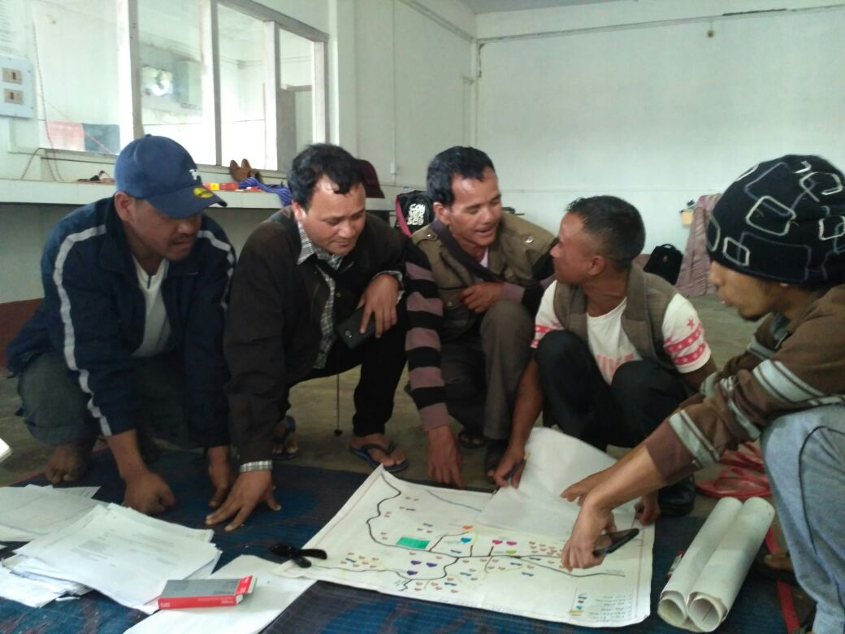

Preparation of route chart with Village Headman

1. Sharing of Information

The following will be the activities that the Social Audit Team will complete over the next three days:

1. Interaction with members of Village Level Committees of all the schemes.
2. Verification of records with members of Village Level Committees. While verifying information from the formats, it is possible that some errors in prefilled information might exist. If there is any dispute in the information in the formats, please access the original documents at the village level maintained by functionaries and documents maintained by beneficiaries. Do not come to immediate conclusions just on the basis of what is said. Please confirm with records before entering findings. Every Social Audit Finding must be attributed to evidence.
3. Conduct interaction with beneficiaries through door to door visits and/or locality meetings. It will be mandatory for the Social Audit Teams to meet every beneficiary. In their interaction with beneficiaries/citizens, members of the Social Audit Team will:
   1. give information about their entitlements
   2. verify records
   3. Document discrepancies between records and beneficiary testimonies
   4. Register grievances beneficiaries wish to file
   5. Facilitate filling up of application forms to be submitted to Line Departments on the day of the Public Hearing.
   6. Social Audit Teams should help prepare a list of all eligible persons who are not existing beneficiaries.
   7. Application Forms should be filled and completed with required documentation for all those who express an interest in obtaining benefits under schemes. This is so that sanctions/approvals/waiting lists can be provided by concerned Line Departments in the Public Hearing as per norms of priority decided in the Public Hearing. Similarly for community benefits needed by the village the social audit teams should explain nature of schemes available, and help create proposals where the village seeks to access such a scheme.
4. Conduct visits to physical works undertaken in the village and all points of service delivery. In its visit to the site of work/point of service delivery, the Social Audit Teams will:
   1. observe quality of the work found on site and discuss utility of work/asset by interacting with users
   2. Verify work site with records entered into the Measurement Book
   3. Verify expenditure booked for in bills/vouchers with actual utilization
   4. Similarly for services, the team will individually and collectively use the prescribed formats to take feedback on prescribed parameters on service delivery.
5. In this duration, the Social Audit Team will conduct at least one evening meeting in the village to spread awareness to the community about social audit and their entitlements.
6. Each day will conclude with an internal de-briefing of the Social Audit Team to exchange preliminary findings.
7. Social Audit Team Facilitator must take measures to share information in the public domain through the course of the social audit verification.

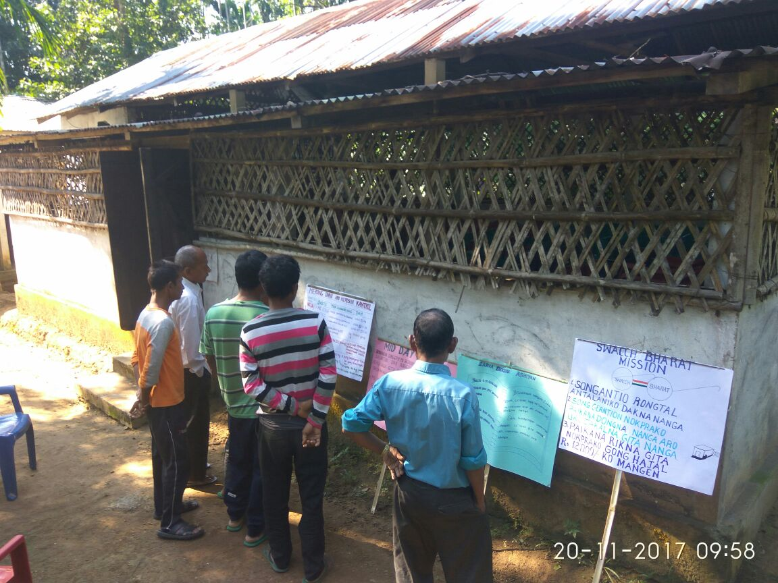

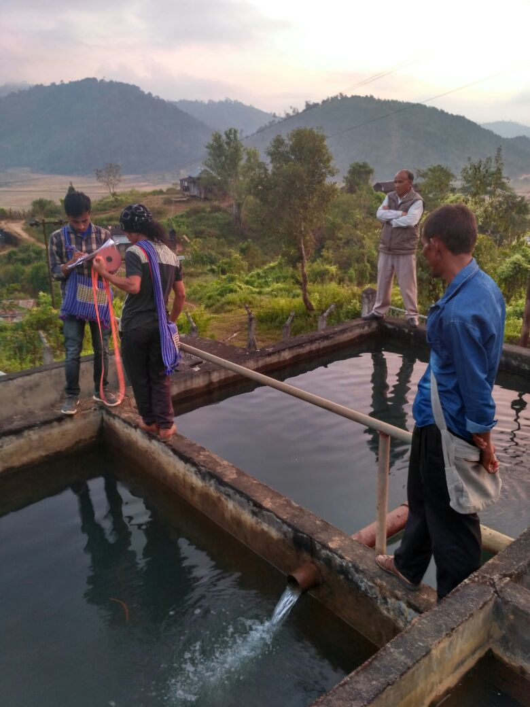

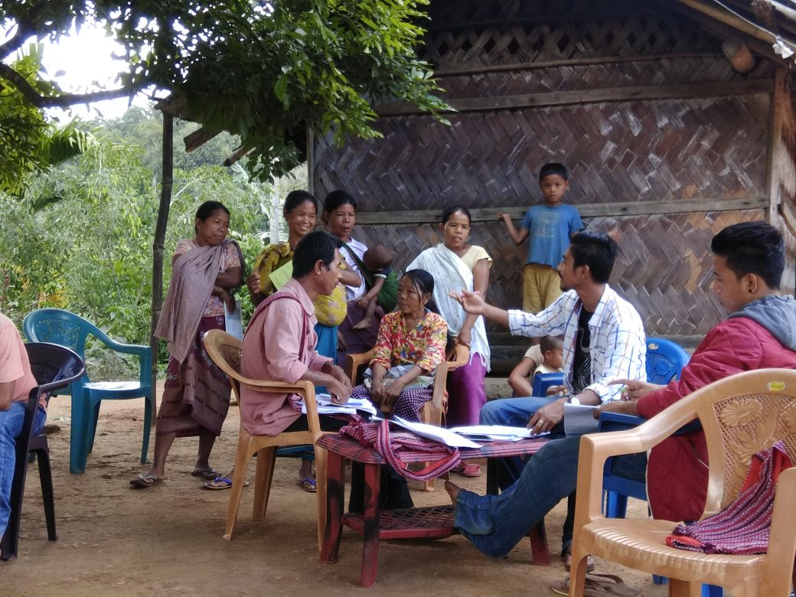

1. Preparation for Public Hearing

The following will be the activities that will be completed by the Social Audit Team on Day 5 in preperation for the public hearing.

* + 1. Consolidation of social audit findings and prepare an agenda of key issues and findings raised during the verification process for discussion in the Public Hearing. The agenda must consist of the following components:
  1. Key findings for each scheme
  2. List of grievances registered for each scheme
  3. List of applications filed for each scheme
  4. Suggested recommendations for strengthening implementation of the schemes in the village
     1. Follow up with the District Administration about the arrangements to be in place for the Public Hearing that shall take place the following day. The Deputy Commissioner will ensure the following:
  5. Line Department Officials of the Block and Village to be present on the day of the Public Hearing.
  6. Line Departments set up individual desks to accept grievances/applications/petitions from citizens.
  7. Attend the Public Hearing personally and depute a nominee for each public hearing taking place in the District.
  8. Ensure provision of a tent, water, sound system, desks and chairs for the Public Hearing.
  9. All proceedings of the Public Hearing are to be videographed.

**Format for Social Audit Report**

**1. Name of Village, Block, District**:

**2. Name of members of Social Audit Support Team:**

a. MSSAT Representative:

b. External Resource Person:

c. Village Resource Persons:

d. Social Audit Committee (if it was formed)

**3. Composition of Social Audit Public Hearing Panel**

|  |  |
| --- | --- |
| Name | Designation |

**4. Number of people who attended the Public Hearing**:

**5. List of Departments which did not set up desks at the Public Hearing**

**6. List of schemes audited by the team in the village:**

**7. Key Findings:**

|  |  |  |
| --- | --- | --- |
| Name of scheme that was audited | Key findings  (Please answer with specific issues listed) | Decision taken at the Public Hearing |
|  |  |  |
|  |  |  |
|  |  |  |

**8. Applications filed by people to avail benefits/services:**

|  |  |
| --- | --- |
| Name of applicant | Name of service applied for |
|  |  |
|  |  |

**9. Grievances/Complaint registered by people indicating irregularity in implementation**:

|  |  |
| --- | --- |
| Name of complainant | Description of grievance/complaint |
|  |  |
|  |  |

10. Based on the social audit findings, please list down **policy level suggestions** that you would like be incorporated in the implementation of schemes that were audited

11. Based on the pilot social audit, please list down the **changes** that you would like be made to the **social audit protocol** that was followed in the pilot and to the **formats** that were used.

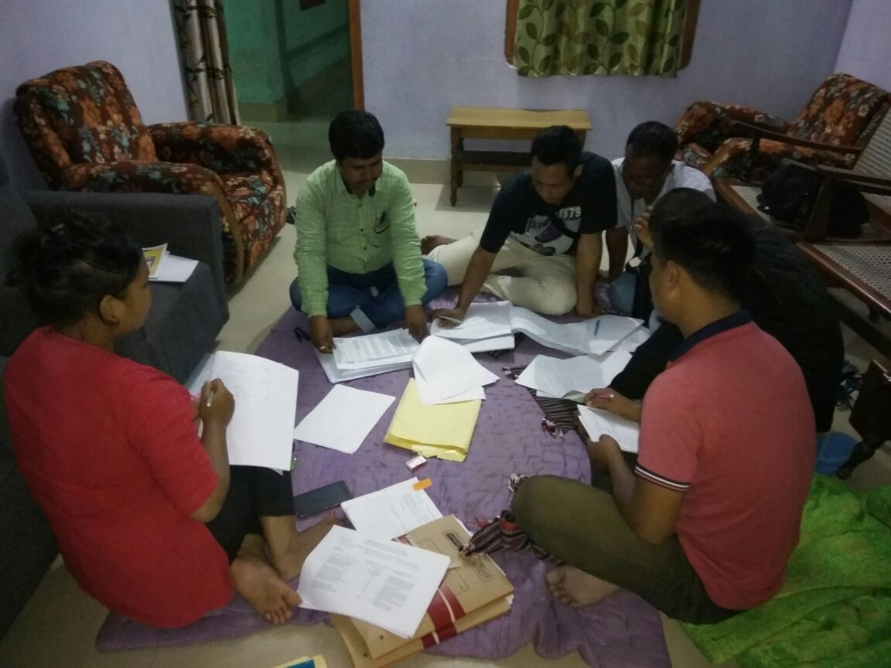

1. Protocol for Public Hearing

The social audit exercise will conclude with a Public Hearing that shall be organized on the 6th day. The Social Audit Public Hearing will be a general body meeting open to all residents (men and women) and members of the Durbar.

* + 1. Members of the Social Audit Team will set up a Single Help/Facilitation Desk which will register all applications.
    2. It will provide two copies of dated acknowledgement receipts for every application and hand it over to the applicant and direct him/her to the appropriate department Desk.
    3. At the Department Desk, the applicant will retain one copy of the receipt and hand over the second copy of the receipt along with the application form to the Department. The Desk will retain a third copy of each individual receipt for the record.
    4. Every Department will be required to set up a desk/counter at the Public Hearing. The counter will be coordinated by the Block Level Implementation Officer of respective departments. The counter will be responsible for:

1. Processing applications/grievances/petitions received
2. Study each application/grievance/petition as per Departmental norms and make its recommendation. If necessary, it will seek clarification from the applicant and obtain required information/approvals from other Departments if necessary.
3. Place all the registers and files pertaining to the schemes implemented by the Department on the desk so that it can be viewed by citizens.
   * 1. The above process is to take place from 09:00am onwards.
     2. Department/MSSAT will print and display flexes to disclose information on the day of the hearing.
     3. 11:00am onwards, the Social Audit Public Hearing will begin. The Public Hearing will be presided by a panel consisting of the following:
4. Village Head
5. Deputy Commissioner/ nominee
6. Block Level Implementation Officers of the various schemes being audited
7. NGO/CSO Representative who is not from the Block
8. Representative of MSSAT
9. Representative of the Autonomous District Council
   * 1. The Social Audit Team will begin reading out the findings of social audit for individual Departments.
     2. Summary of the information pertaining to the scheme and its expenditure will be read out. This will include summary of the applications filed on the day of the Public Hearing and the response of the Department on the same. Applicant/Complainants will be given a chance to comment on the response of the Department in front of the panel.
     3. Findings of the social audit will be read out. This will include case studies, individual testimonies etc. Participants will be given a chance to intervene and comment.
     4. The Panel will have to take a decision/make recommendation on each finding which will be announced and recorded in the minutes.
     5. The minutes of the meeting will be taken by a representative of the MSSAT

Grievance Form

|  |  |
| --- | --- |
| 1. Name of complainant |  |
| 2. Name of Village, Block and District |  |
| 3. Name of scheme for which grievance |  |
| 4. Description of grievance |  |
| 5. List of documents attached |  |
| 6. Signature and date |  |

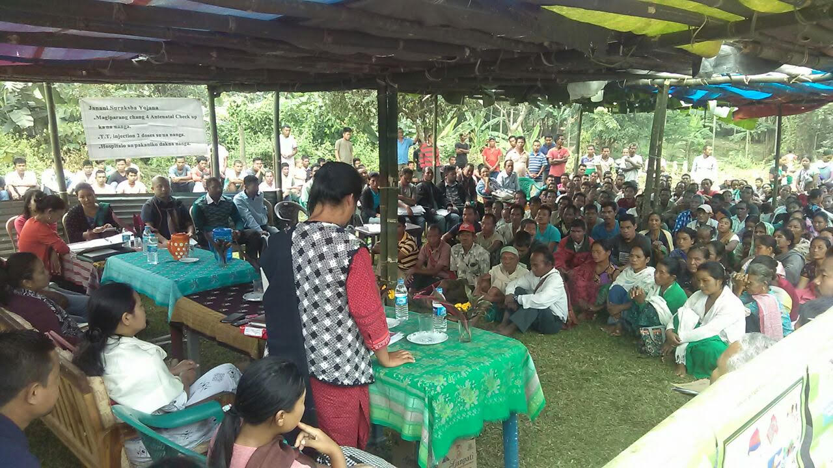

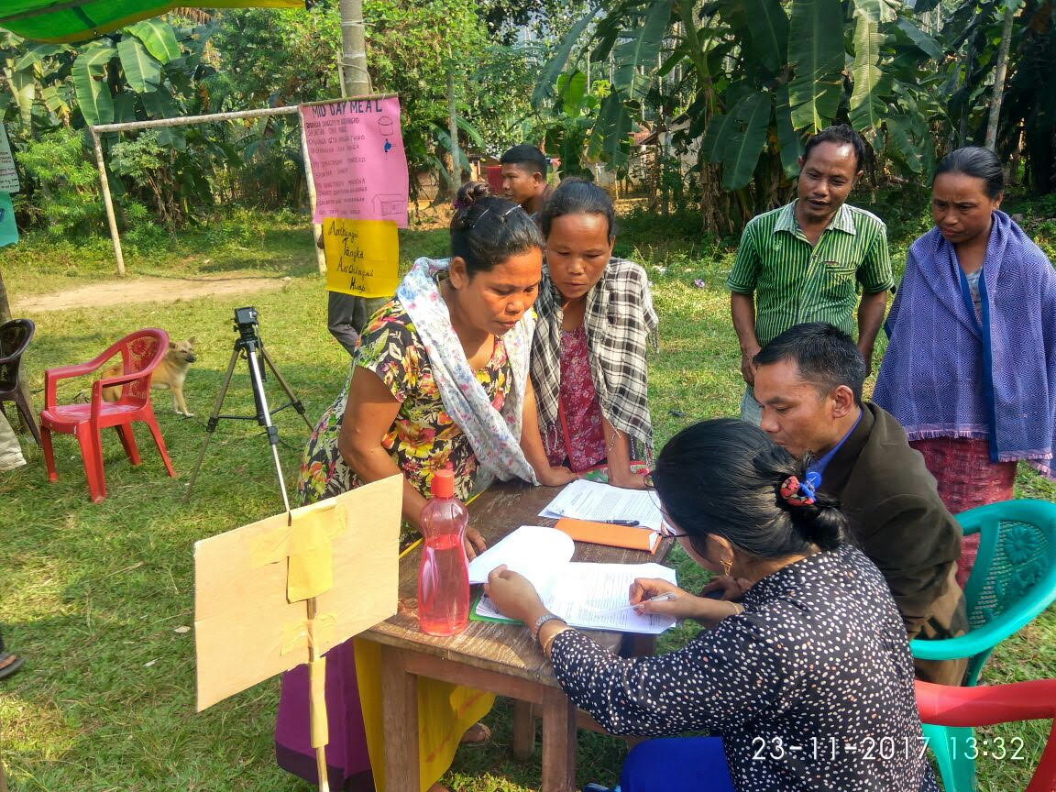

VII. Follow Up

* + 1. For all applications seeking individual/collective benefits, if the applicant qualifies, the applicant should either be awarded sanction on the day of the Public Hearing itself. In the case that sufficient resources aren’t available to accord sanction to all those who have applied, a priority based waiting list should be created which should be announced in the Public Hearing.
    2. On Social Audit Findings, the Panel will give its recommendations which will also be read out. Individual Departments will submit an Action Taken Report on findings of the social audit to the Deputy Commissioner within 15 days. Subsequently, a meeting of the Deputy Commissioner and the Autonomous District Council should be held within 30 days of the Social Audit Public Hearing to review findings and status of action taken. All decisions of the meeting will be recorded and made available in the public domain.

VIII. Code of Conduct

Social Audit Support Team has a very important and responsible role to play in ensuring that the process of social audit maintains a high standard of integrity and ethics. The team has been entrusted with a task of supporting people in accessing their rights and entitlements and bringing into public gaze any shortcomings there might be in implementation. Because this often involves asking uncomfortable questions and bringing out irregularities and even cases of corruption, the team members themselves and their behaviour are under constant focus and attention. They have to follow a particularly high standard of ethics and mature behaviour to maintain the credibility of the entire social audit process. For this reason, it is essential that all social audit support team members consider and sign a code of conduct and ethics and follow this sincerely while they are assisting this process.

1. Team members will maintain all accounts of expenditure for the social audit and be ready to share this in a transparent manner
2. Team members will take care to respect local cultural norms and customs and not speak rudely with anyone. There will be particularly careful not to respond to provocation but report any untoward incident to the group leader.
3. There will be no consumption of alcohol or other addictive substances by any team member during the course of the audit. No team member will discriminate on the basis of gender.
4. Team members will pay for their own food and accommodation will be organized by MSSAT following a simple lifestyle.
5. Hospitality will be avoided from any member of any implementing agency.
6. Team members will understand that they must live in the village and a social audit process continues round the clock. Any person in distress who comes and asks for assistance will be heard and supported as per the protocol of the social audit.
7. Team members will be courteous with each other and any difference of opinion will be discussed and sorted out in a daily team meeting. If any team member has a serious problem that they feel they cannot sort out within the team, they may call MSSAT.
8. It will be the duty of every team member to try and ensure that unheard voices reach the social audit public hearing. People, particularly vulnerable individuals and local groups, can speak out free of fear. Team members is only playing a supportive role. Team members are not the auditors. The people are the auditors. Response and redressal shall come from the Government. Therefore the team should not provide any false assurance. Team members must make sure that whatever they say is backed by evidence and documents. Any questions that people ask must be responded to in the full spirit of transparency.
9. Team members will record their observations and findings (as per the formats) and will attempt to make sure that the concerned people attend the social audit public meeting, and their issue is discussed.
10. Team members will avoid any situation where they might be seen to have a personal interest for or against any matter.
11. The independence of the social audit process must be maintained at all times.

**Sample Pamphlet**

**Our Accounts - Our Money**

**Pilot Social Audit under “The Meghalaya Community Participation and Public Service Social Audit Act, 2017”**

Social Audit is a process in which public inspects all the records related to different welfare schemes and programs along with physical verification, quality check, utility, achievements and the difference which these brought in the life of public. This is done with the public participation and monitoring

Financial Audit only involves inspection of proper utilization of finances but Social Audit not only involves inspection of proper utilization of finances but also involves inspection of quality of work and the difference it brought in the life of the public. Social Audit is next step of Financial Audit.

One aspect of Social Audit is to find any irregularities, but more important aspects are to find whether public is getting their rights and entitlements or not, whether schemes are being run with their right spirit as per the defined norms or not and whether benefit of schemes is being passed to eligible and appropriate beneficiaries or not. At the end of this process, a public hearing is organized which provides a fear free platform to public to place any grievance, opinion or suggestion, especially to the most marginalized people.

In order to establish this democratic process of Social Audit, Meghalaya is one of the first states which passed “The Meghalaya Community Participation and Public Service Social Audit Act, 2017” in March, 2017.

**Appeal**

Social Audit Support Group appeals the following to participate in this process and bring appropriate documents (like Ration Card, Job Card, Bank pass book, Aadhaar Card, etc):

* Anyone who has availed scheme benefit
* Anyone who is eligible but hasn’t been able to avail benefit
* Any new eligible applicant
* Anyone having a grievance or demand

Locality meetings will be organized which will involve spreading awareness about different schemes and corresponding entitlements, public records and expenditure will be read out, new applications will be filled and any grievance will be recorded.

Public Hearings will be organized in a prominent place in village at … location at …. time in which stalls related to different schemes where new applications can be submitted and any grievances/opinion/irregularity will be addressed through a public platform.

**Issued in public interest by-**

Meghalaya Society for Social Audit and Transparency (MSSAT)

Lower Lachumiere, Shillong, Contact No.- 0364-2500551

ENTITLEMENTS

|  |  |  |
| --- | --- | --- |
| S.No | Name of Scheme | Entitlements |
| A. | Mid Day Meal Scheme | 1. Hot cooked meal every day in school for all children enrolled  2. Adequate drinking water is available to all children  3. A cook should be appointed  4. Cook should come to school every day and cook hot meals for everyone  5. There should be a standard menu that should be displayed publicly  6. The cook should follow the regular menu  7. The cook should be paid regular honorarium  8. There should be a teacher in the school who will monitor the activity of the cook  9. SMC should be formed  10. SMC should be trained  11. Should respond to concerns, decisions and feedback from the SMC  12. SMC should monitor the Mid-day Meal program regularly. |
| B. | Sarva Shiksha Abhiyan | 1. All children between the age group of 6-14 years get free education  2. Textbooks to all children in Government/Local Body and Government aided Schools, within an upper ceiling of Rs. 150/- per child at primary level and Rs. 250/- per child at Upper Primary Level.  3. Two sets of unfirms for all girls, and children belonging to SC/ST/BPL families in Government schools within a ceiling of Rs, 400/- per child per annum  4. Adequate infrastructure  5. Adequate teaching and non-teaching resources are made available  6. School is accessible  7. All children in the age group are enrolled  8. SMC should be formed as per the norms  9. SMC should be trained  10. Allocates money for School Grant and Maintenance grant  11. Forms Parent Teacher Association and holds regular meetings  12. Should respond to concerns, decisions and feedback from the SMC  13. The School Management Committee should make an annual School Development Plan and monitor the functioning of the school |
| C. | Public Works Department and PMGSY | 1. Villages/Communities should have access to an all weather road; Roads may be built under Pradhan Mantri Gram Sadak Yojana (PMGSY), MGNREGS or under other schemes including Member of Parliament Local Area Development (MPLAD), MLA Local Area Development (MLALAD) and Fourteenth Finance Commission Grant (FFCG)  2. PMGSY roads can be built for villages with a population of more than 250 persons and habitations within 1.5 km  3. Construction of roads, approach roads, link roads, Pathways under MPLAD  4. Other schemes under which roads can be built are   * General State Plan * Special Plan Assistance (S.P.A.) * North Eastern Council (N.E.C.) * Special Accelerated Road Development Programme SARDP-NE * Non-Lapsable Central Pool of Resources (N.L.C.P.R.) Funded by Ministry of DONER * Central Road Fund (C.R.F) * Inter State Connectivity (I.S.C) * Asian Development Bank (A.D.B.) |
| D. | Forest Management | 1. Entitle to receive financial support for doing Plantation and Regeneration works and other non forestry works as per the National Afforestation Programme norms.  2. An adult member from each household of the village shall constitute the General Body of the Joint Forest Management Committee (JFMC).  3. 25% of the Executive committee shall consist of the women representatives.  4. assist or make suggestion during the Preparation of micro plan, work programme  5. Choose species to be planted.  6. Suggestion of Physical and financial targets.  7. Proposal of Entry point activities.  8. Entitle to Environmental awareness programmes  9. Entitle to Fund creation activities  10. Regeneration and protection of forest and wildlife.  11. Entitle to grievance redressal of Complaints |
| E. | Public Health Enginnering Department | 1. Access to adequate quantity of water for every households inside and close to the house 2. Safe drinking water to every households 3. Safe drinking water should be available at public location including schools, ICDS centre and health centre 4. Department consults people when it plans to implement water supply projects and that it implement the projects in a transparent manner |

|  |  |
| --- | --- |
| F. Name of the Scheme | Janani Suraksha Yojana (JSY) |
| Objectives | To provide cash assistance to pregnant women who have completed the 3 ante-natal boosters and to encourage Institutional delivery in all Government Health Institutions across the state. |
| Entitlements/ Benefits | Entitlement for pregnant women:   * Free cash assistance of Rs 700/- (in rural areas) and Rs 600/- (in urban areas) directly into their bank account   Entitlement for ASHA worker:   * Incentive of Rs 600/- (in rural areas) and Rs 400/- (in urban areas) given, if the ASHA promotes & accompany the pregnant women for institutional delivery |
| Mode of selection of beneficiaries/ Eligibility | All pregnant women BPL, non- BPL who have completed the 3 ante- natal boosters and who go for institutional deliveries are eligible. |
| How to avail/ apply | The beneficiaries can avail this scheme from any public health institutions in the state and should provide MCP card, JSY card and their bank account. |
| Conditions | 1. If the pregnant women did not complete the 3 ante-natal boosters, then she will not be eligible for the scheme but if the pregnant women has completed the 3 ante-natal boosters and went for home delivery she will still be eligible for the scheme (preferably should be BPL & will get Rs 500/-). 2. If the ASHA accompanies the pregnant women to health institutions she will get Rs 600/- but if the ASHA did not accompany the pregnant women to health institutions, she will only get Rs 300/- as an incentive. 3. If the beneficiary do not have a bank account then she will not get the cash assistance |

|  |  |
| --- | --- |
| G. Name of the Scheme | Janani Shishu Suraksha Karyakram (JSSK) |
| Objectives | JSSK is a free and cashless services to pregnant women including normal deliveries and caesarean operations and also treatment of sick new born (upto 1 year of age) in all Govt. Health Institutions across the State. This scheme places utmost emphasis on entitlements and elimination of out of pocket expenses. |
| Entitlements/ Benefits | Entitlement for pregnant women:   * Free and Zero expense delivery and caesarean section * Free drugs and consumables * Free essential diagnostic (Blood, Urine Test, & Ultra- Sonography etc) (ANC & PNC upto 6 weeks) * Free diet during stay in health institutions ( upto 3 days for normal delivery & 7 days for caesarean section) * Free provision of blood * Free transport from home to health institution * Free transport between facilities in case of referral * Drop back from institution to home after 48 hrs stay * Exemption from all kinds of users charges   Entitlement for Sick Children (Upto 1 year of Age):   * Free and zero expense treatment * Free drugs and consumables * Free diagnostics * Free provisions of blood * Free transport from home to health institution * Free transport between facilities in case of referral * Drop back from institution to home * Exemption from all kinds of users charges |
| Mode of selection of beneficiaries/ Eligibility | All pregnant women and sick children upto 1 year of age are entitled to avail such benefits |
| How to avail/ apply | The beneficiaries can avail this services from any public health institutions in the state , whereby the provisions of drugs and consumables, diagnostics, diet, ambulance service ( referral transport) and blood are facilitated and are given free of cost to the beneficiaries |

|  |  |  |
| --- | --- | --- |
| I. | Integrated Child Development Scheme (ICDS) | 1. from pregnancy (9 months) to six months after the child birth, women are entitled to free nutritious food- take home ration. It should have 600 Kcal and 18 to 20 g protein. 2. Take Home Ration will be available for children in the age group 6 months to 3 years through the Anganwadi Centre. The food should have 500 Kcal and 12 to 15 g protein 3. Morning snacks and Hot Cooked Meal in the day for children age 3 years to 6 years through the Anganwadi Centre. The food should have 500 Kcal and 12 to 15 g protein 4. every Anganwadi Centre shall have facilities for cooking meals, drinking water and sanitation. 5. The local Anganwadi Centre shall identify such children who are suffering from malnutrition. Those malnourished children who are in age group of 6 months to 6 years will receive Take Home Ration. This food should have 800 Kcal and 20 to 25 g protein.  6. every pregnant woman will be entitled to financial benefit of Rs. 6000/-. There shall be no rider of eligibility like that of belonging to BPL for availing this this provision.  7. |
| J. | Pradhan Mantri Awas Yojana (PMAY) | 1. Eligible beneficiaries can receive Rs 1,30,000 as financial grant to build a house and loan facilitation for upto 70,000  2. Use SECC data to prepare list of eligible beneficiaries based on exclusion and inclusion criterion and prioritize the list based on deprivation scores  3. Submit the priority list to gram sabha for verification and redress grievances  4. Publish the final priority list |
| K. | ASHA Workers | 1. Create awareness and conduct outreach programs among the community regarding nutrition, basic sanitation, hygienic practises and healthy living  2. Counsel women on birth preparedness, importance of safe delivery, breast feeding, complementary feeding, immunization, etc  3. Accompany the pregnant women requiring admissions to the nearest PHCs  4. Visit the baby born at hospital and home for checking their weight , fever, etc. |
| L. | Village Health Nutrition & Sanitation Committee (VHNSC) should | 1) Be formed at the village level  2) Have minimum 15 members with 50% women  3) Appoint Headman as the Chairman, ASHA as the Secretary & Convener of the Committee  4) Meet once in a quarter  5) Gets Rs. 10000 per year as untied grant from the Government every year and use it as per the norms  6) Organise Village Health Nutrition Day (VHND) once every month; immunisation should be given to all pregnant women and children of less than 5 years on this day  7) Identify locally available foodstuffs of high nutrient value  8) Facilitate early detection of malnourished children in the community  9) Acts as a grievance redressal forum on health and nutrition issues |
| M. | Health Centre | 1. Sub Centre should be open daily for providing counselling and Ante Natal check- ups to all pregnant women; should provide free medicines for minor ailments to all patients who have approache the Sub Centre.  2. Sub Centre should refer emergency cases to the Primary Health Centre  3. Primary Health Centre should provide all the services rendered under Janani Shishu Surksha Karykram (JSSK) which includes normal delivery services for 24 hrs every day; free diagnostics, free medicines & services to all patients and free referral services from PHC to CHC/higher level facility to all pregnant women and emergency cases.  4. Primary Health Centre should provide Janani surksha Yojna (JSY) Benefits to all entitled women.  5. PHC/CHC should utilize the Rogi Kalyan Samiti (RKS) funds mainly for the welfare of patients which includes food facility to admitted patients and their relatives, basic facilities for ensuring comfort of patients (drinking water, sitting arrangement), cleanliness, emergency medicines etc.  6. Community Health Centre should provide all the services rendered under Janani Shishu Surksha Karykram (JSSK) which includes complicated delivery services (including Caesarian), free diagnostics especially X ray and ultrasound services and free referral services from CHC to District Hospital/higher level facility to all pregnant women and emergency cases |